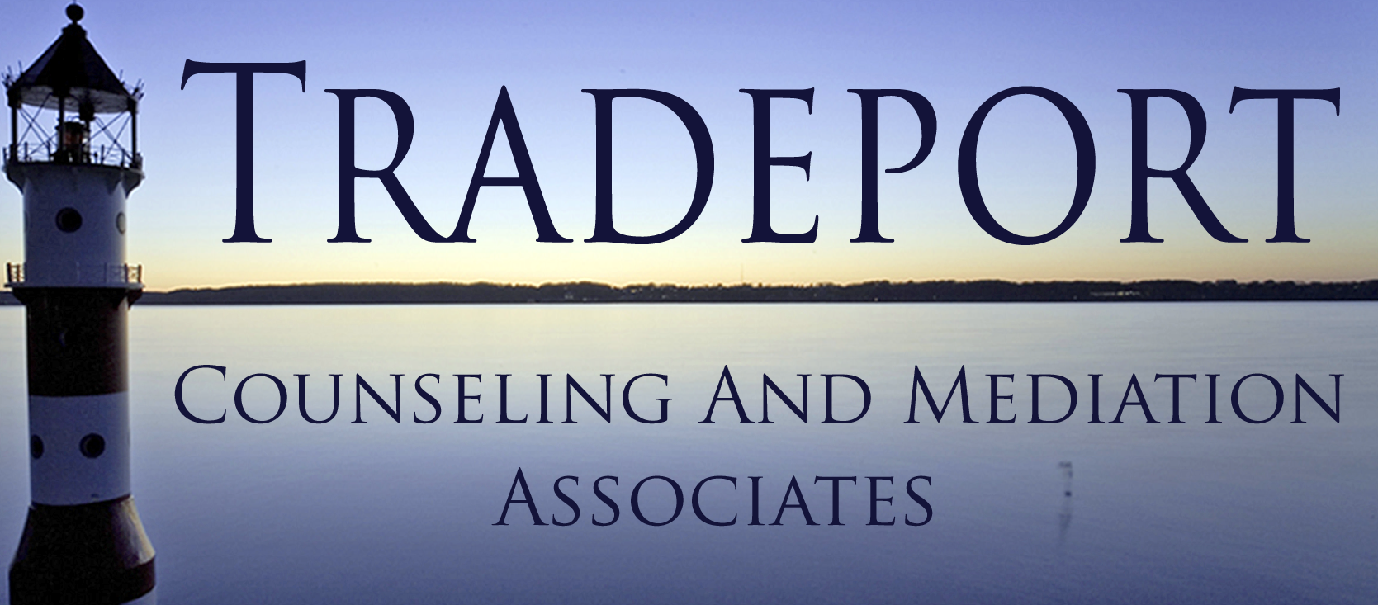
TRADEPORT COUNSELING AND MEDIATION ASSOCIATES
200 INTERNATIONAL DR. STE 157
PORTSMOUTH, NH 03801

(603) 957-1877
(603) 812 4586

TRADEPORTCOUNSELING@GMAIL.COM
WWW.TRADEPORTCOUNSELING.COM

TCMA STAFF

Tracey Tucker, LCMHC

Kit McCann, LMFT

Hayley Langmaid, LCMHC

M. Kate Knight, LICSW

Lauren Gulla, LICSW

Stephanie Bielik, LICSW

CONSENT FOR TREATMENT FORM

I ____________________________ hereby authorize Tradeport Counseling and Mediation Associates, PLLC to provide counseling for myself and/or the following minor(s), of whom I am the parent or legally constituted guardian.

NAMES OF MINOR(S):

Child Name:_____________________________________________
Date of Birth:______________________

Child Name:_____________________________________________
Date of Birth:______________________

Records that need to be kept in your confidential file will be as follows, as according to HIPPA:
- The presenting problem(s), purpose or diagnosis
- The fee arraignment
- The date and services provided
- A copy of all tests and evaluative reports prepared
- Notation and results of formal consults including information obtained from other persons or agencies through a release of information
- Consent for Treatment
- Release of Information Forms

Date:____/____/____ Signed:_________________________________________

Date:____/____/____ Clinician Signature:________________________________

