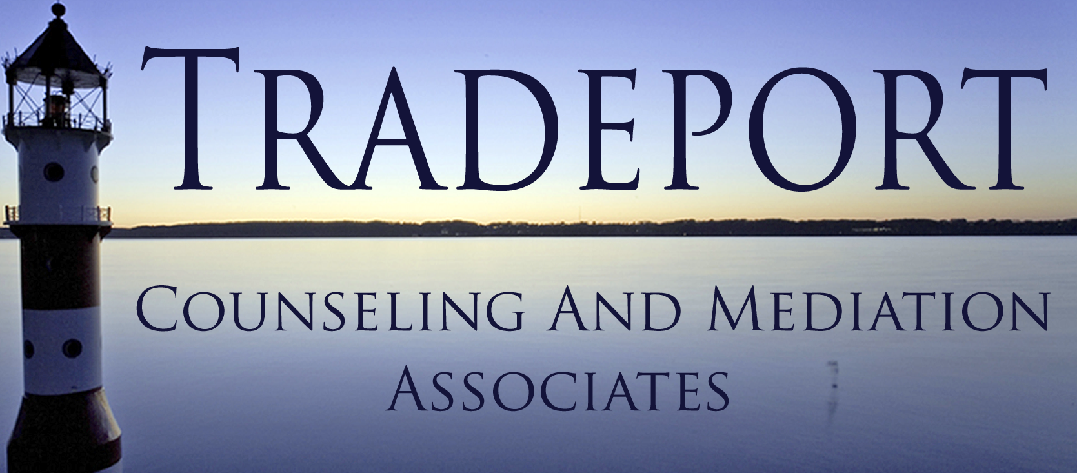
TRADEPORT COUNSELING AND MEDIATION ASSOCIATES
200 INTERNATIONAL DR. STE 157
PORTSMOUTH, NH 03801

(603) 957-1877
(603) 812 4586

TRADEPORTCOUNSELING@GMAIL.COM
WWW.TRADEPORTCOUNSELING.COM

TCMA STAFF

Tracey Tucker, LCMHC

Kit McCann, LMFT

Hayley Langmaid, LCMHC

M. Kate Knight, LICSW

Lauren Gulla, LICSW

Stephanie Bielik, LICSW

CONSENT TO RELEASE OF INFORMATION FORM

I ____________________________________ hereby authorize Tradeport Counseling and Mediation Associates, PLLC, and

Name:_____________________________________________________________

Address:___________________________________________________________

City/State/Zip:______________________________________________________

Name:_____________________________________________________________

Address:__________________________________________________________

City/State/Zip:______________________________________________________

To release to each other any/or all medical or psychological information they have concerning myself and/or following minor child (children) of whom I am the parent or legal guardian.

Child Name:_____________________________________________DOB:___________

Child Name:_____________________________________________DOB:___________

Child Name:_____________________________________________DOB:___________

I understand this information is essential to the continuity of care for the above named individuals and will be kept confidential and used for professional purposes within the office only.

Date:____/____/____Signed:____________________________________________

Date:____/____/____ Clinician Signature_________________________________

