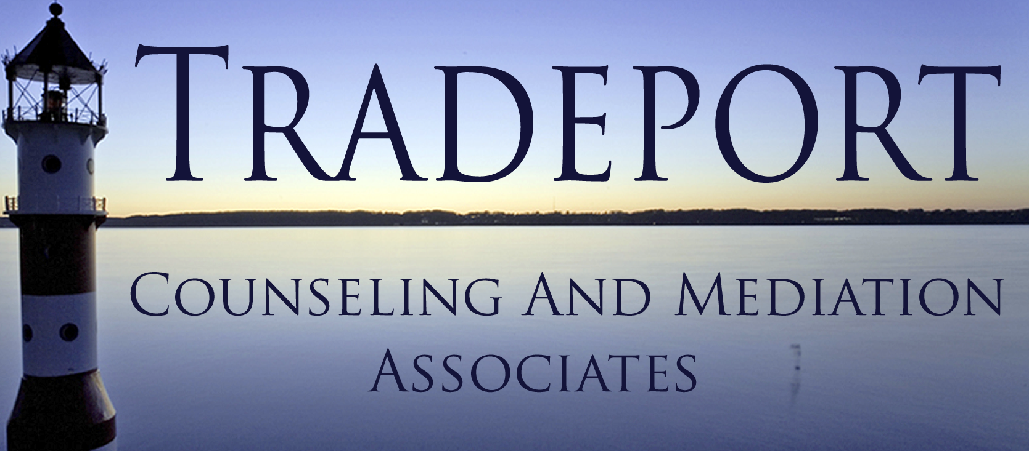
TRADEPORT COUNSELING AND MEDIATION ASSOCIATES
200 INTERNATIONAL DR. STE 157
PORTSMOUTH, NH 03801

(603) 957-1877
(603) 812 4586

TRADEPORTCOUNSELING@GMAIL.COM
WWW.TRADEPORTCOUNSELING.COM

TCMA STAFF

Tracey Tucker, LCMHC

Kit McCann, LMFT

Hayley Langmaid, LCMHC

M. Kate Knight, LICSW

Lauren Gulla, LICSW

Stephanie Bielik, LICSW

SPECIAL AGREEMENT FOR PAYMENT OF SERVICES

I _________________________________________agree to pay Tradeport Counseling and Mediation Associates, the amount of $___________________ at the close of each scheduled or arranged therapy session. Upon termination of therapy, I agree to pay Tradeport Counseling and Mediation Associates, either 1) the balance on the account; or 2) the amount of $______________per month until the account is paid in full. Accounts thirty (30) days or more past due will be assessed a finance charge of 1.5% of the unpaid balance.

I understand that this agreement is an addendum to the primary agreement for services, which I have also signed.

I have read the above agreement and understand my responsibilities as set forth in this said agreement and will abide with the said terms as stated above.

Date:____/____/____ Client Signature:___________________________________

Date:____/____/____ Clinician Signature:________________________________

